What is cloud computing?

Cloud computing, according to the official NIST definition, is "a model for enabling ubiquitous, convenient, on-demand network access to a shared pool of configurable computing resources (e.g., networks, servers, storage, applications and services) that can be rapidly provisioned and released with minimal management effort or service provider interaction." (http://www.nist.gov/itl/csd/cloud-102511.cfm) When an application is run "in the cloud", it is merely saying that the hardware and network level infrastructure that an application runs on is provisioned as part of an independently managed and dynamically allocated set of hardware. This infrastructure can be managed on-site by the same organization that deploys the applications running on top of it. In this case, the applications are said to run on a "private cloud". A "public cloud" is one where the physical hardware and networking infrastructure is managed one company, which is exposed as a service for customers to rent. Public cloud offerings can include data storage options, as well as a range of computational and networking power.

IaaS vs PaaS vs SaaS

Cloud computing services are often touted as "Infrastructure as a Service" (or IaaS), because it enables customers to rent out infrastructure, owned by the provider, in order to run network applications. These applications can be managed by the custom themselves; in some cases their are "Platform as a Service" (or PaaS) offerings that can run on top of these infrastructures that are managed by the provider (e.g. Google App Engine, Amazon Elastic Beanstalk, Heroku). However, unlike Software as a Service (SaaS) offerings, the top level applications that use IaaS and PaaS services are developed and maintained by the customer.

### Google App Engine ###

Knock out early, since it doesn't follow the whole Instance-Block Store-Object Store concept.

Cloud Service Concepts

Servers

Servers are rented from a public cloud service provider on an hourly basis, although in some cases servers can be reserved for more time for a discount. The servers appear to be completely isolated machines, as if you were renting a physical computer that you could log into, install software on, etc; however in reality the servers exist as one of many virtual machines running on very powerful hardware in data centers owned by the cloud service provider. Virtual machines allow one computer to operate as several other computers (the virtual machines), with each of the virtual machines sharing the hardware resources of the host. So when you are renting a server from a cloud service with 4 CPUs, 8 GB of memory, and 800 GB of storage space, what you really are renting is a virtual machine that is provisioned from it's host machine 4 CPU's worth of processing capacity, 8 GB of the host's memory, and a 800 GB section of the host's storage capacity. Externally, however, it seems as though the server is a completely isolated and independent machine, capable of running any software that a physical device with similar specifications could.

Object Store

Public cloud service providers often offer a storage mechanism that allows for redundant storage of high volumes of data to be accessed by servers. The redundency of storage happens when your data is copied to multiple data centers in different geographic locations, which allows for one whole datacenter to fail and you data to remain safe and backed up. It is called 'object storage' because it is unlike a normal file system on a regular hard drive. The files, or objects, are accessed through an HTTP interface, unlike a regular file system. This allows for access to the data from anywhere in the world. It cannot, however, be used as a backing storage device for things like filesystems and databases, except through third party software packages.

Block Storage

Block storage devices act as though they were physical devices that can be hooked up to a server as an external hard drive would. They can be formatted to any file system, and can provide fast access to large amounts of data. Block storage services can be used to save data of server instances past the lifetime of servers; the instance storage that is provided with server instances only live as long as the server does. If a block storage volume is used on the instance, the data on that volume can be persisted after the server is deleted, and can be attached to another server in the future so that the data may be used. Block storage generally provides quicker access to data than object storage, but is less redudant (although redundency does exist for block storage services).

Load Balancer

Load balancing is a technique to distribute workload across two or more servers. It can aid greatly in the number of requests that your application can handle. It also can prevent outages, because if a range of servers are serving requests, and one goes down, the others can still service the requests. Load balancer offerings are unlike server offerings in that you do not get to install any software on the load balancer or make it do anything besides route traffic. You can manage server pools and choose routing algorithms, but other than that the server is outside your control.

Topology

A computer network topology is a description of the arrangement of systems in a computer network. When an application runs on a cloud platform, all of the servers, load balancers, and datastores used to serve that application are part of the cloud topology. The most simple topology is a single server. A more complex topology might include various application servers running in different data centers, that are accessed through an array of load balancers, which use databases run on different servers, which are backed up by different object stores. The good design of a cloud topology is what enables applications to scale well, to be resilient, and get the most performance out of your application for the price.

AWS

Amazon Web Services was launched in 2002 as a service for developers of other web sites for use in their own application. Amazon eventually expanded their offerings to an entire suite of infrastructure services. It is now the leader in cloud services. Their cloud products are vast, with many server and storage options, as well as load balancers, monitorying, managed databases and more. Large, high traffic sites such as Netflix, Reddit, Pinterest, and many more rely on AWS to run their products.

AWS has had serveral highly publicized outages, including one in December 2012 that caused many sites to not function for a large part of the US. [http://aws.amazon.com/message/680587/] The outage was caused by a developer running non-production maintanence procedures against production state data, deleting the data necessary for existing load balances from their Elastic Load Balancing service to continue to run. A section load balancers in the US-East region began failing, and many sites became unavailable, including Netflix streaming services for devices in US, Canada, and Latin America [http://techblog.netflix.com/2012/12/a-closer-look-at-christmas-eve-outage.html]. At the peak of the disruption, 6.8% of all AWS load balancers were impacted. In March of 2011, Reddit became unavailable for periods of the day due to a failure in the EBS product in one of Amazon's availability zones (one physical data center) [http://blog.reddit.com/2011/03/why-reddit-was-down-for-6-of-last-24.html].

Dispite these outages, AWS has been very consistent in keeping it's large network of services nominally running. As Miles Ward, a Solutions Architect at Amazon puts it, EBS volumes "are made of real world things and as a result they are subject to potential failure." [http://www.youtube.com/watch?v=vXkBvuAM7T4&list=FLKTzS-1lnetuksXY3C-XtIQ] EBS volumes " that operate with 20 GB or less of modified data since their most recent Amazon EBS snapshot can expect an annual failure rate (AFR) of between 0.1% – 0.5%, where failure refers to a complete loss of the volume. This compares with commodity hard disks that will typically fail with an AFR of around 4%, making EBS volumes 10 times more reliable than typical commodity disk drives." [http://aws.amazon.com/ebs/] Failure is an enevitability in distributed systems, and the best way to get around it is to design systems that are fault tolerant at the application layer. In reddit's postmortem blog post about it's outages due to the March 2011 EBS failures, it does take onto the development team much of the blame for not distributing data across availability zones, or using RAID configuration on some servers. This is to say that, although Amazon's outages have received a lot of public attention, and may deter use of their services, the fact that so many high profile companies rely on AWS's stable services so much that even a half day of issues causes so much press speaks to the stability of the system; the outages are the exceptions that prove the rule.

OpenStack

OpenStack is not a cloud service provider per say but a set of open source software tools that are used to manage a cloud hardware infrastructure. It can be run on a variety of hardware, including private and public clouds, and there are a number of commercial providers that use it to manage their public cloud offerings, such as Cloudwatt, DreamCompute, eNocloud, HP, and Rackspace. The software was developed for the most part by Rackspace, and has contributions from NASA software that they used to run their private data centers.

One reason that is often advertised by OpenStack cloud implementors is that there is 'no vendor-lockin'. By this they mean that, because Open Stack is open source software that is implemented on a number of public cloud providers, one could theoretically move cloud service providers without changing much of their cloud deployment and management development. For example, if you have a script that manages a set of servers on a Rackspace deployment, then if you were to choose to move your application to HP Cloud, then there would be minimal change to that script, and it should just work with the new Open Stack deployment. This overused point is weak on two points: first off, switching providers will mean changes to scripts no matter if they are using the same API. Server names will be different, offerings will be different, so a script that spins up servers on Rackspace will necessarily need to be modified to account for the different accounts and server types. In fact, the idea that moving an application from one cloud provider to another without making changes is a bad idea: mapping the topolgy over from one deployment to the other without considering the differences between the servers, storage, load balancers, etc is a sure way to introduce accidental performance issues. An application running on one topology will not behave the same on another, even if they look similar enough between the two providers. So serious considerations and modifications will need to be made when switching cloud service providers, whether it be between two OpenStack providers like Rackspace and HP, or between Amazon and an OpenStack provider. However, if one develops their deployment software correctly, then those modifications can be pushed out of the underlying core functionality, so that switching which servers deploy what and when can be made in an isolated, easy to change spot. This brings me to the second weakness in the 'vender lock-in' point: if the deployment software is developed correctly, then switching between an AWS and EC2 API should be as easy as switching out libraries. There are a number of open source libraries that already operate on either the AWS or OpenStack API. For instance, jclouds, advertised by HP Cloud as it's JVM language bindings, supports a full range of cloud service provider API's: Amazon, GoGrid, Ninefold, vCloud, OpenStack, and Azure. The calls to the language bindings between the platforms are not the same, or based on a simple setting, but developing a layer over the specific calls to allow for the various APIs be called correctly per vendor is not a difficult way to prohibit lock in from the client side. Vendor lock-in is not something that can be gaurenteed by a cloud service provider, but it can be almost elminated with good development practices.

NASA currently uses both OpenStack and AWS. NASA CIO Linda Cureton responeded to questions about why NASA would not only use OpenStack, since it is software that they helped create and are contributing to, by saying "our computing strategy for cloud now, is to choose the right cloud strategy for the right environment. Everything is not OpenStack. OpenStack, I think, has a great value when you look at features that aren't necessarily there in the commercial providers. For example, if you have some very specific security requirements or if you are dealing with extremely large datasets, looking at a solution like OpenStack starts to tip the scale to that. But your run of the mill, general purpose type web servicing, a lot of commercial providers have been doing that for a while, and they do that very effectively and so OpenStack needs to compete with that, but I think the big value for OpenStack is with their customized needs."

OpenStack seems to be a good choice if you want a powerful open source platform for running a private cloud; for example NASA and CERN are using OpenStack at their private data centers. However, as mentioned there are companies who use OpenStack to manage powerful public clouds. In particular HP and Rackspace have offerings that compare with AWS: similar server configurations that can be dynamically resourced by the hour through an API or web console, block storage devices that can be attached to these servers, and object store services for highly redundant storage of large amounts of data.

Comparison of platforms

What follows is a visual comparison of server offering from Amazon Web Services, Rackspace, and HP. The graphs compare the servers by amount of RAM provided, number of CPU's provided, and the hourly price of the server. The size of the point indicates the server's storage capacity, relative to the other servers in the graph. The red points that are marked as a star indicate that the Amazon server provides no instance storage, but instead would use EBS storage as it's primary storage mechanism (with additional charges applying). Note: Amazon advertises it's instance memory specifications in GibiBytes (GiB), not Gigabytes (GB), where 1 GiB = 1.024 GB. All memory specifications in the charts below are in GB.

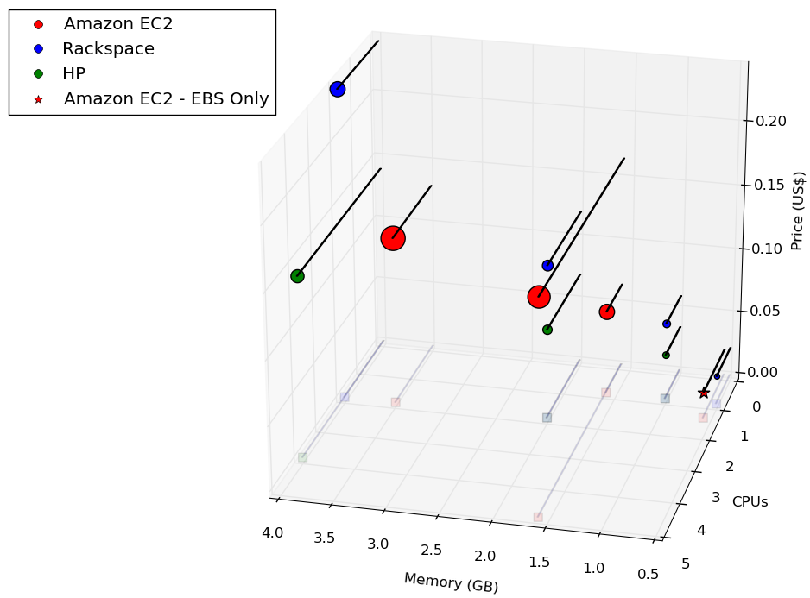

Above shows the least expensive offerings from Amazon, HP, and Rackspace. As can be seen, Rackspace servers quickly become significantly more expensive than their HP or Amazon counterparts. They all show a general trend up as far as performance goes, with a couple notable exceptions: the one Amazon server with the most CPU and the highest price is a specialized instance, the c1.medium, which is part of the High CPU instance family (as explained in a below section). It provides a relatively large amount of CPU power for the the amount of memory, as compared to it's m1.small offer, which has the same amount of memory but much less cpu power. The hourly rate reflects this specialization. Another exception is that the HP Medium instance is very close in price and memory to the Amazon m1.medium, but has twice the CPU capacity.

To compare performance between the similar offerings from Rackspace, HP, and Amazon servers, I ran two performance tests. The first runs a simple jetty web service on each of the servers, and runs an Apache Bench benchmark, running locally, against that service. There are two endpoints, one doing a Hillshade algorithm against a Raster data structure in a parellel fashion (taking advantage of all the cores of the machine), and the other is a simple weighted overlay between two rasters. In each case the raster size is 256x256. As we can see from the first benchmarking result, the HP beats out both Rackspace and Amazon in the time per request as well as the requests per second. Notice that although the rackspace server has the same CPU assignment as the Amazon server, with only slightly more memory, but performs consistently better in this benchmark than the Amazon server.
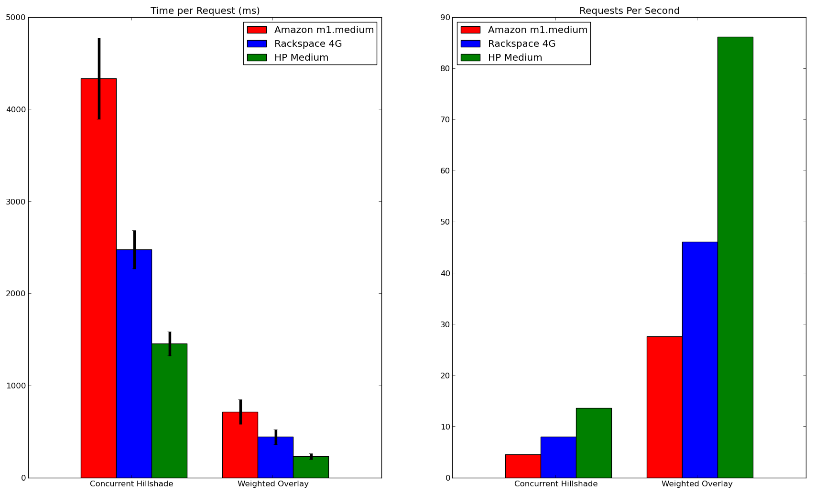
In the second test, Google Caliper benchmark tests were run on each of the machine. The benchmark tests below operate on array and raster data in Scala, and can be found at https://github.com/lossyrob/cloud-benchmark/blob/master/server/src/main/scala/Services.scala. Here are the results:
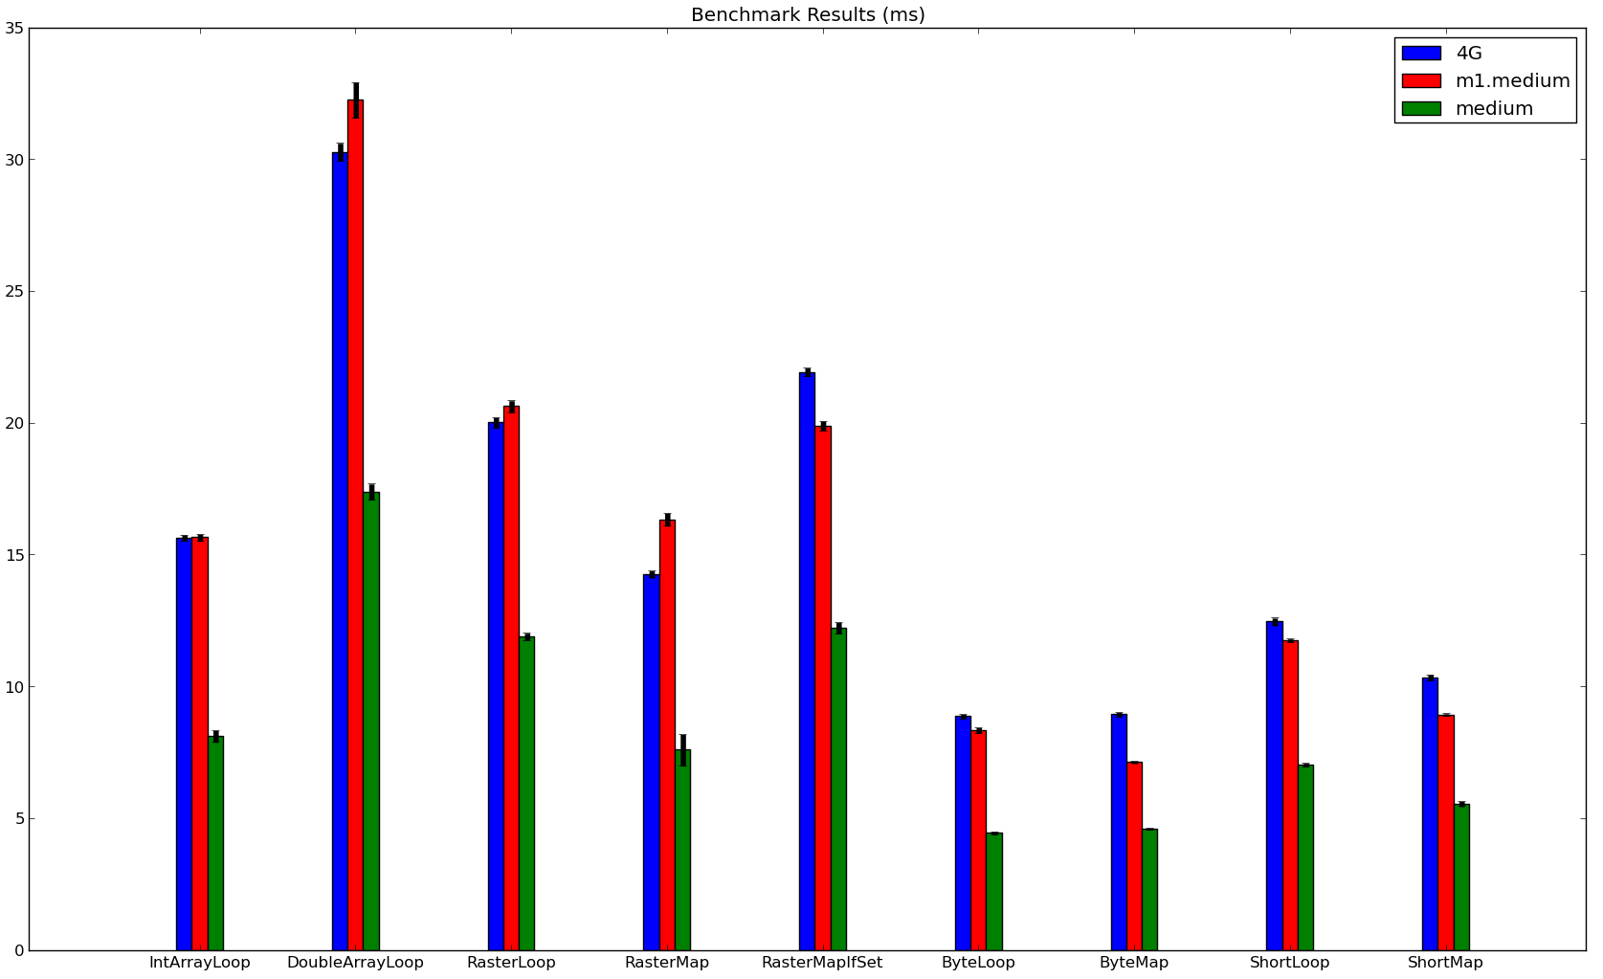

Again the HP machine beats out both. However, we can see that the results between the Rackspace and Amazon machines seem inconclusive as to which is the more performant.

As an aside about benchmarking, I'd like to point out that any benchmarking results should be taken with a grain of salt. As explained above, these servers are virtual machines, and do not run in isolation. They run on a host computer along with a myriad of instances provisioned to other customers; the overall load on the host computer can certainly affect the performance of a specific instance. Therefore, the results from a test done during a time of relatively low network activity in the host data center can be very different from running test during a period of time where the network is beign slammed. As much as this variance of performance is minimized by cloud providers, it ultimately exists, and must be understood and worked with. In addition to this source of variance, there are many other sources of variance, such as operating system processes taking up CPU time, garbage collection schedules inside the software platform, system time reporting variance, benchmarking software executiong variance, to name a few. Benchmarking data should be understood as an approximation of performance. While this may seem to say benchmark data is not to be trusted and therefore not useful, it happens that when the variance is understood and acknowledge, conclusions can still be made from the more general trends of the data.

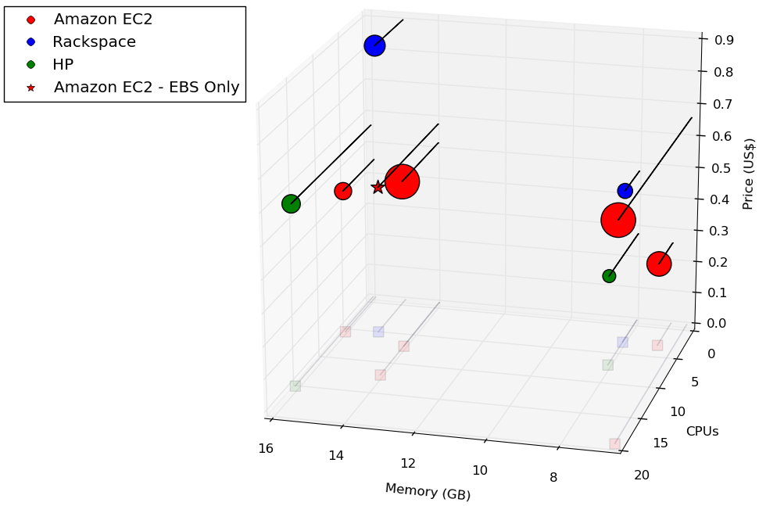

The above graph depicts the larger offerings of the three providers. Here we start to see Amazon's offering dominance; while both Rackspace and HP offer only 2 servers in this range, Amazon has different offers to choose from. Again there is a close match between HP and Amazon in price and power for their extra large offerings. The m1.xlarge and m3.xlarge offerings both have 15 GB of memory, as opposed to the HP Extra Large offering, which has 16 GB. The HP server also has twice as many CPU units as the m1.xlarge. The m3.xlarge Amazon offering has closer to the HP's CPU capacity, with 13 CPU units, but does not have an instance storage and costs a little more. Here is how they performed against each other with same benchmarks:

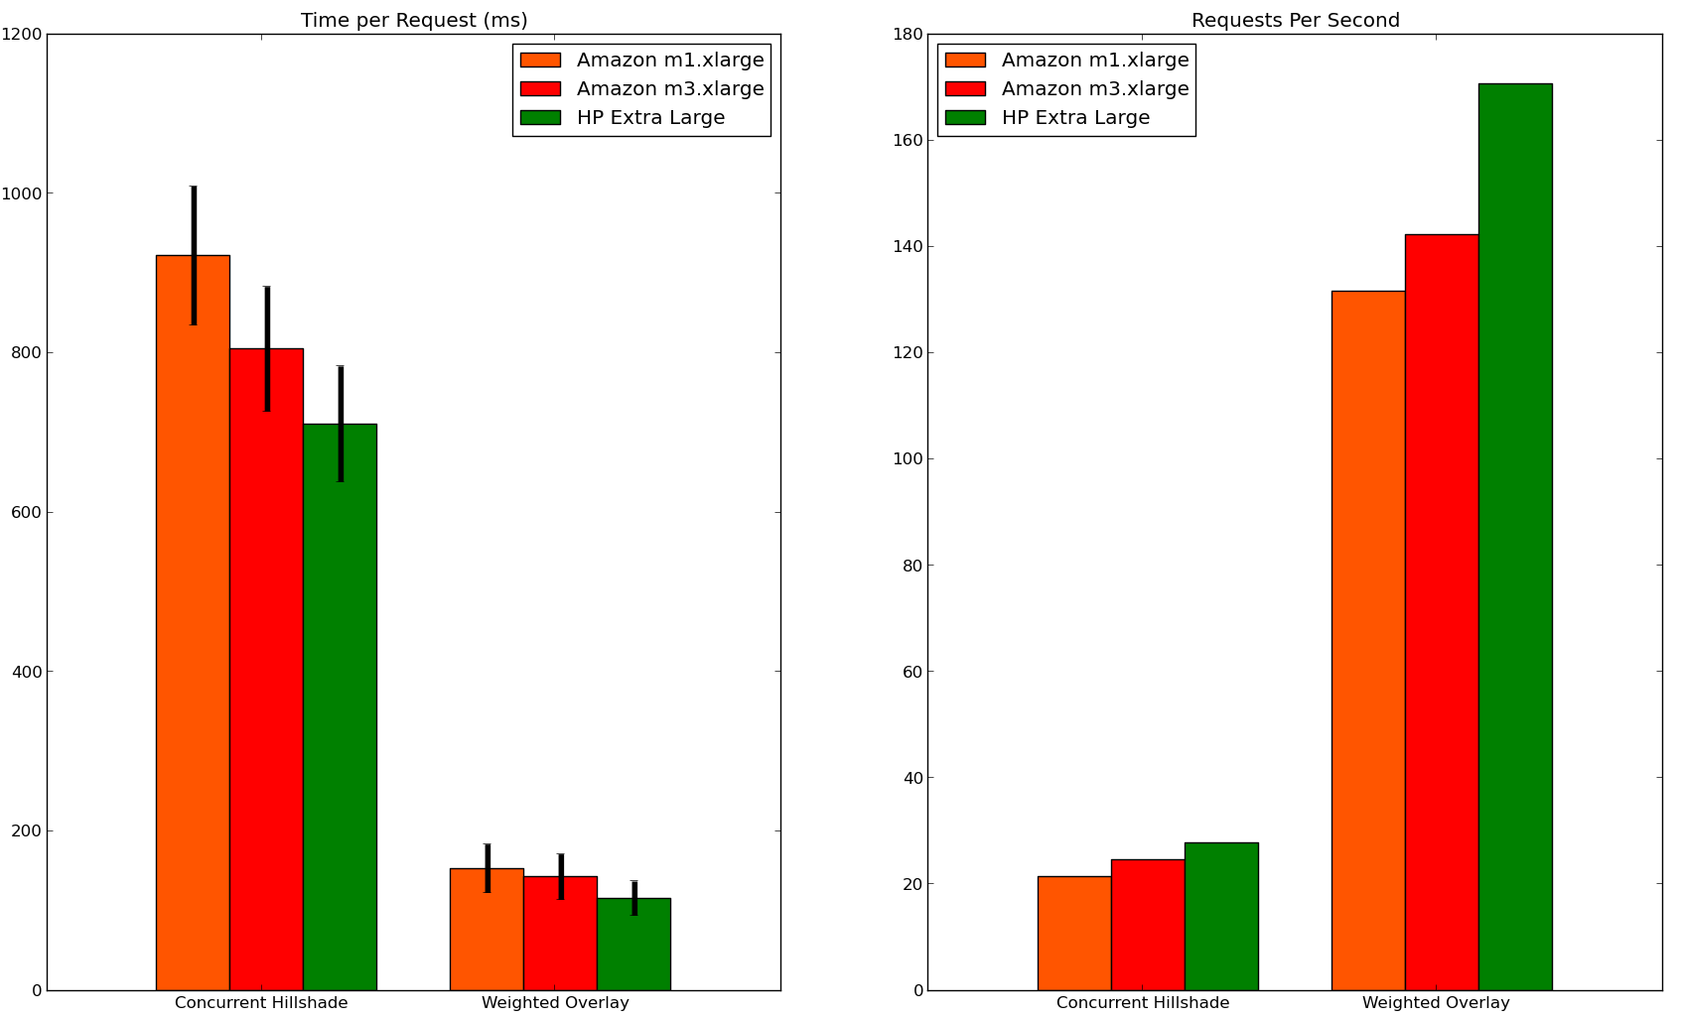

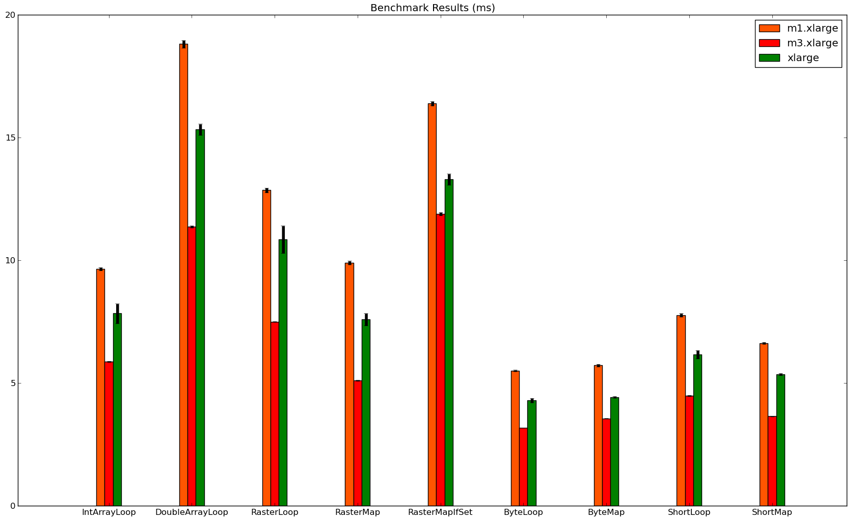

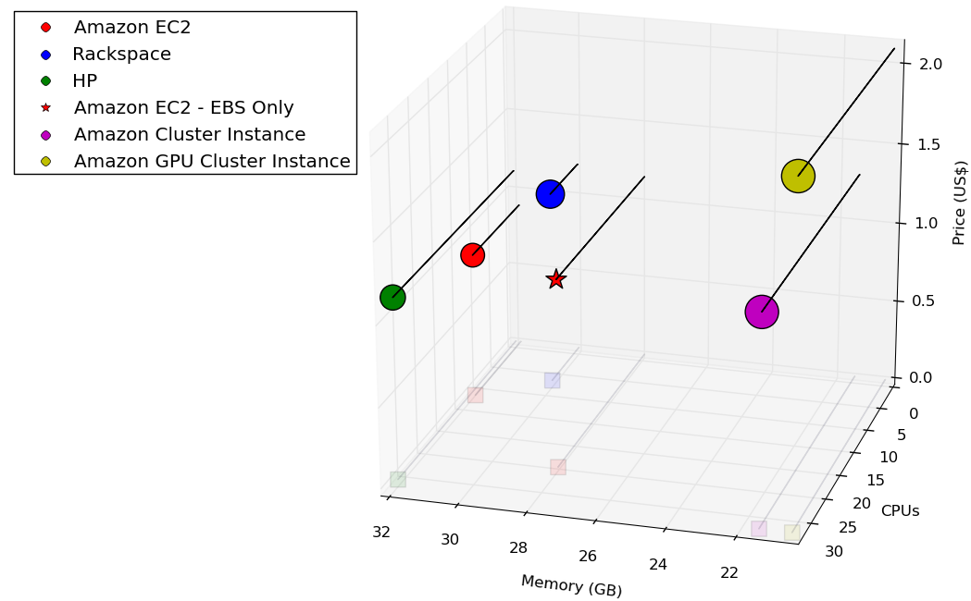

Here we see the largest instances that HP and Rackspace offer, as compared to similar offerings from Amazon. Again, Amazon is a clear winner in the depth of their offerings. Amazon offers the m2.2xlarge high memory instance, the m3.2xlarge high CPU instance, as well as two different cluster instances, which have performance benefits outside of the CPU, memory, and storage capacity dimensions that they provide. HP is again the leader in number of CPUs for the price, as seems to be the trend.

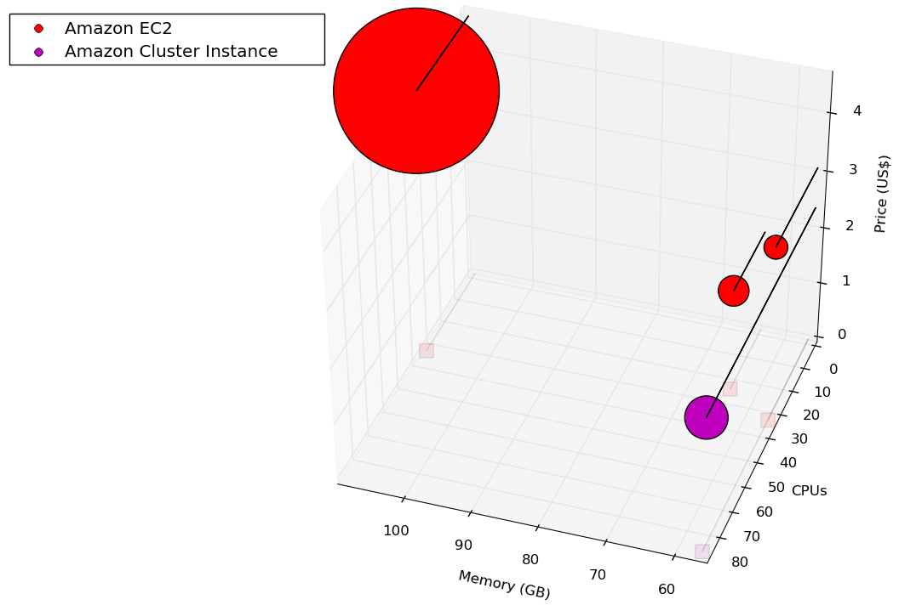

Lastly, we have Amazon's highest performing offerings. The giant on the left side is the hs1.8xlarge High Storage instance. These are high performance data warehousing machines, and you certainly pay for the power ($3,422.40 for a long month). There is a High I/O instance and a Cluster instance, both having benefits not apparent in the graph, as explained a section below. Then there is the m2.4xlarge, which gives you 68.4 GiB of memory

Product Offers

As mentioned above, Amazon clearly has the most diverse offerings in server types.
HP does not currently offer load balancers.

Quality of Service

Rackspace is touted as having 'fanatical support' (you can't go very far with anything to do with Rackspace with out hearing that catch phrase). From personal experience with them and through reviews it seems as though they try their hardest to live up to the phrase. However, other parts of the Rackspace cloud experience have been frustrating. Through my experience I've seen a significantly slower spin up time of rackspace servers as compared to HP and Amazon EC2. In some instances, the server building status would be stuck at 83% complete for hours. In one set of cases as I was benchmarking, there were a number of server build requests that were reported back as errors, only to pop up a significant time later as built. If I hadn't been checking the dashboard, I would not have known these servers had actually been build and that they were being charged to the account.

HP has a an easy to use dashboard, and it was very easy to set up an security groups and key pairs and get started spinning up instances. Instance creation was very fast, and I'm not sure which was faster, creating an EC2 instance or an HP instance. I received an automated call from them a week after creating my account, which listed a series of HP cloud services and where I could get help. Not being interested in automated telephone solicitation, I hung up. A couple of days later, I got an email saying my account had been suspended, because they could not validate 'important details' about my account. I did not read through the whole email, as the account was made purely for benchmarking purposes and I had more important things to attend to that day. The next morning I received an email that my account had been cancelled, saying that HP had attempted to contact me 'multiple times'. Luckily I had all the benchmarks done and didn't need to redo any of them, so I did not have to go through the account setup process again. This is a small incident, of course, but I'll leave it to you to decide whether this could speak to how HP handles customers.

Working with Amazon's dashboard and API has been a pleasure.

Amazon offers the widest range of services, including basic services such as servers (EC2), storage (S3 and EBS), and load balancing, as well as managed databases, auto scaling, monitoring, and data processing services. Cloud platforms like Rackspace and HP offer subsets of what Amazon offers, so it is good to look to Amazon to see what other cloud platforms are going to mature into, and for cutting edge offerings. In the following section we will look more closely at Amazon's cloud offerings.

As stated, Amazon groups it's server instances into families, each with their own characterists, strengths, and weaknesses. The amazon ec2 documentation located here [http://docs.aws.amazon.com/AWSEC2/latest/UserGuide/instance-types.html] is a rich source of information about the specific instance types. I will breifly summarize the family types here.

Micro – At the time of writing, there is only one micro instance available. It has no instance storage, and little CPU power, that is decribed as Amazon as 'bursty'. Micro instances are for when you need small increments of CPU resource for cheap, for a duration. For example, say you had a server running diagnostics, and was in charge of status messages incoming from the entire topology. It is important that the server not drop any of the incoming status information, so you would want the server to remain dedicated to that job. If you had a periodic data aggregation task that you did not want to use the diagnostic server's CPU on, you could copy that data to an EBS volume, take a snapshot, spin up a set of micro instances with EBS volumes based off of that snapshot, and have the micro instances do the work.

Standard – These instances are good general purpose servers, with CPU power balanced with memory resources. There should be a good reason for using a server of another family than standard, like needing a different CPU to memory ratio, or requiring more tuned performance.

High-CPU and High-Memory– These instances provide a different cpu-to-memory ratio than the standard instances. High CPU instances would be useful for tasks that require a lot more computational power relative to the amount of data it works on; high memory instances would be useful for cache server or other tasks that require a large amount of memory to be stored in memory.

High-I/O – These instances are equipped with Solid State Drives as instance storage and 10 Gbps network bandwidth to maximize data transfer.

Cluster Compute – Cluster instances have a large amount of computational power and increased network badwidth. They are most useful in High Performance Computing (HPC) applications, where large amounts of data and\or computationally expensive algorithms are distributed across a cluster of instances. There are instances which have graphical processing units (GPUs) available for doing HPC on media, or for taking advantage of GPU utilizing frameworks such as CUDA or OpenCL.

High-Storage – High storage instances give an enourmous amount of instance storage (48 TB), as well as increased sequential read and write speeds from the storage. In addition, with 117 GB of memory, these instances and 10 Gbps network throughput, this instance has it all, that is, except for CPUs; it only has 16 CPUs to work on all that data.

Below is benchmarks against the first generation standard instance offerings, as well as a second generation instance (the M3 Extra Large Instance).

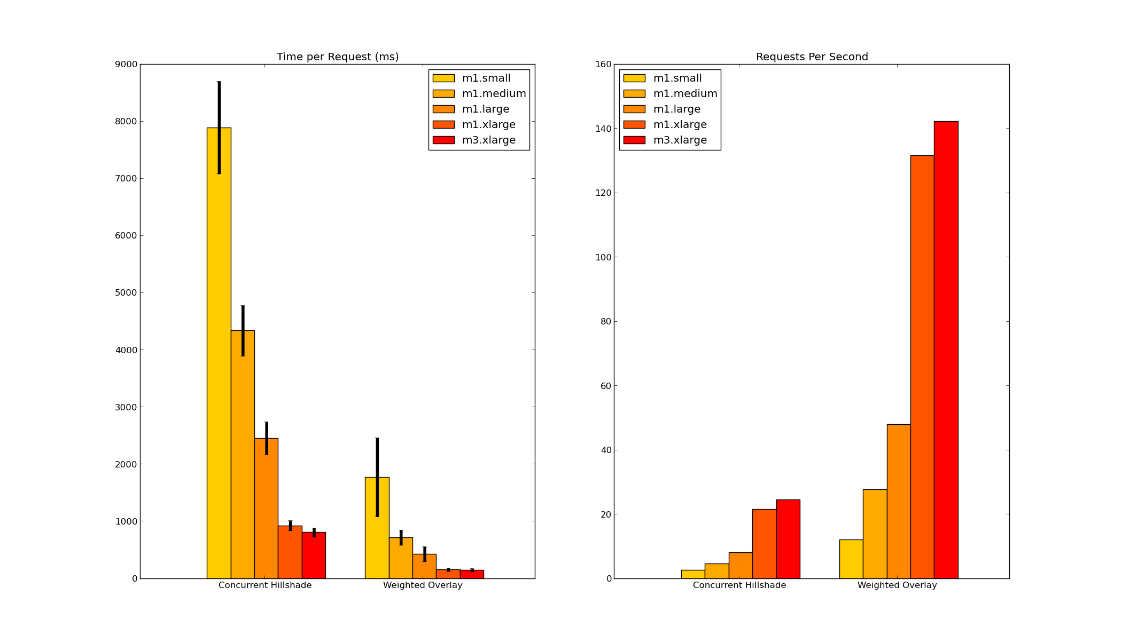

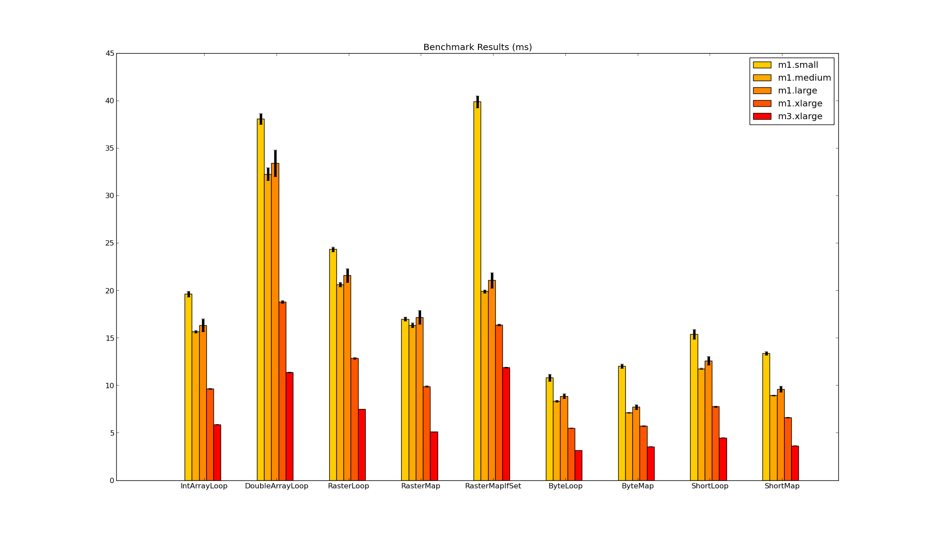

Storage options

Instance Storage

Instance storage refers to storage from disks that are physicall connected to the computer hosting the instance as a virtual machine. Each instance (except for EBS-only storage instances) come with a specific amount of provisioned storage, which is dedicated to the instance. The physical disk that provides the instance storage is shared among instances of that host computer. One important difference between instance storage and the other storage types is that the storage will only last as long as the server. Once a server is terminated, either due to failure or by the user, all data on the instance storage is lost. It is therefore severly recommended against using instance storage for any permenant data; it is useful only as an ephemeral block storage device that is physicall connected to the server.

EBS

Elastic Block Storage, or EBS, is a block storage service that makes available to EC2 instances a device that appears as any other block storage device would look: an external hard drive, a thumb drive, etc. It can be formatted and mounted, configured in a RAID configuration, or even as the main file system for some instance types. It provides permenent storage in that EBS volumes are provisioned seperately from instances. When you terminate an instance that has EBS volumes attached to it, the volumes do not terminate with the instance (unless specified to do so); the data remains, and can be accessed by reattaching the volume to another instance. Another measure to ensure the durability of data is that EBS volumes are replicated over their availability zone (data center). This means that it would take a data center-wide EBS failure to lose your data (which has happened, see Reddit anicedote above). Their EBS offering also allows you to take snapshots of volumes, which can be used to create identical volumes at a later time. The snapshots are stored in S3 in a compressed incremental format, which means two things: the S3 charges for the volume will be for less gigabytes then the actual volume size, and that you only get charged for the amount of data changed for susiquent snapshots. For example, if you have a snapshot of a 100GB drive, change 1 GB of data, and then take another snapshot, the additional charge for the second snapshot will only be the S3 charge for whatever the compressed 1 GB would amount to.

pIOPS EBS

Amazon EBS has a offering called 'Provisioned IOPS' (pIOPS). What this means is that EBS volumes are provisioned a set number of IOPS to be used; the volume will operate within 10% of the provisioned IOPS 99.9% of the time. Whereas standard EBS is a best-effort service, pIOPS is a metered service. Each individual I/O transaction service time is metered. If you provision 1000 IOPS for a volume, each individual I/O operation should take 1 ms. An I/O is defined at reading or writing one 16KB block. These numbers are important to understand in order to utilize pIOPS correctly. If your application does not fill the IO queue with 16 KB operations in a way that utilizes all of the provisioned I/Os per second, then you are wasting money; you still pay for the provisioned IOPs that you don't use.

Performance comparison

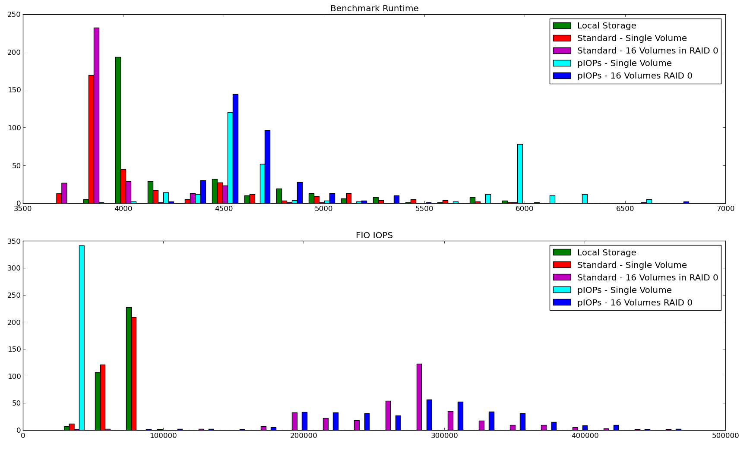
Load Balancers

Load balancers can help improve the performance and resilience of a cloud-based application. Below is results of a benchmark that measured performance of medium and large standard instances, alone and when using a load balancer infront of two (2) or four (4) instances. The requests were sent from our Philadelphia office to instances hosted on the US East region of EC2. The service request returns a 256x256 PNG. The same test run on a single m1.xlarge instance is provided to give comparison.
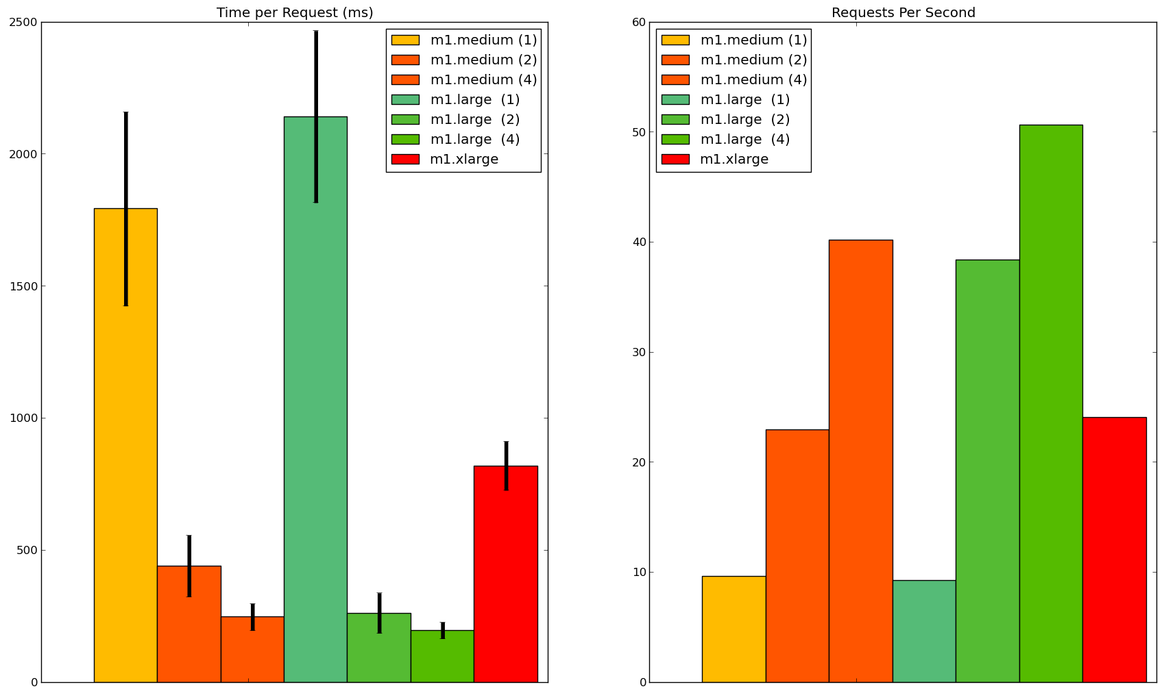
The results indicate that in certain applications, two standard medium instances behind a load balancer, while being cheaper than one standard extra large instance, could be more performant.

Conclusion

Amazon is leading the way, and has the best options for flexibility in developing a cloud topology on which to deploy your application. However, there are companies that are trying to loosen Amazon's stronghold on the market. In my opinion, given HP's history in server hardware design, it has the best chance for taking on Amazon Web Services. If HP can diversify it's offerings to match Amazon's, I think that HP will be a very good choice. However, their cloud offering is not mature enough to recommend at the time of writing, so if you need more than a simple network topology, or plan to scale to a more complex topology, I believe that Amazon EC2 is the best choice.

Footnotes:
All code can be found at https://github.com/lossyrob/cloud-benchmark

All graphs made with NumPy, SciPy, and matplotlib, and can be found at https://github.com/lossyrob/cloud-benchmark/tree/master/client/charting

